New Life in Creation Week One

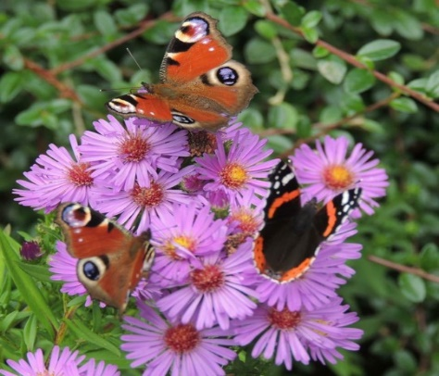

Introduction 15 mins – spend some time sharing a little about yourselves and why you are doing the course. Pray for your group.

New Life in Creation. This week we are thinking about creation and about Genesis 1. We are not opening a debate about evolution and creation but rather we will reflect on creation passages in the Bible and look at what they tell us about the nature of God and our relationship with him.

Opening Worship – Read Psalm 8 in groups of A and B how do you react to it, what does it say about Gods power? Spend a few moments in prayers of thanksgiving for the wonderful World God has given us.

Genesis 1:1 – 2:3 Take around 15 mins to read the story individually and note down anything that strikes you. Read it slowly allow it to sink in. You will think you know it but there is always more to find in God’s Word. Notice how many words imply energy and movement and growth, notice how God is portrayed.

Share with the group what each of you found. What struck you particularly?

What does it tell us about God and his purposes for us? What is ‘man’ told to do?

Notice the wording of vs26 in 2 or 3 different versions. The implication is that Men AND woman are made in Gods image. How comfortable are you with thinking about God as having female as well as male qualities?

Look at the wording of vs 28. what to you feel God calls us to do in creation? Rule? Subdue? ‘Govern’ (NLT)

What kind of King /ruler is God? So, what does this imply about our care of the Earth, what kind of things should we be doing?
Summing Up
Getting ready
In week 4 your group will take part in a project to reach out to and bless your community. This may be in your usual meeting time slot or at some other point in the week but each week you will have time to plan for it. A large group might even plan two!
Think about the environmental needs in your local community, litter/pollution? Lack of green space? How might you bless your community in week 4?

We say together:

‘2 Corinthians 5:17, Therefore if anyone is in Christ (they) are a new creation; old things have passed away; behold all things have become new.*

Our sins are forgiven, let’s live our new life in the love of God.’

For next week, bring a cross (of any type, picture, model, crafted.) to look at during the opening reflection.

Psalm 8

All Wonderful God, Creator,
The whole earth declares your greatness.

A Your glory glows in the Heavens.
It is babbled by babies and sung by children.

B You are safe from all your enemies:
You have made us only a little lower than yourself;
And crowned us with glory and honour.

B You share with us the responsibility
To care for sheep and cattle, wild things, birds and fish,
everything that lives in the sea:
to work with you, within creation.

A Wonderful God, Creator,
The whole earth declares your greatness.
Those who oppose you are silenced.

A When I look to the sky, which you have made,
the moon and stars that you set in place.

B Where do human beings fit in the pattern?
What are we that you care for us?

Taken From the Iona Abbey Worship Book copyright The Iona Community

