New Life in the Community Week 4

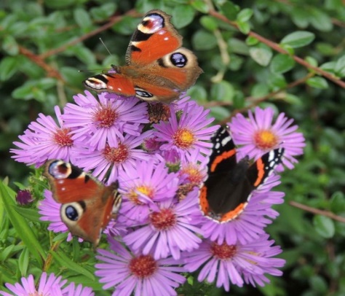
Introduction
This week is about putting into practice all that we have learned. You may not even meet on the same might as previous weeks or it may not be convenient to start and end the evening together. If possible share in the prayer below or if you are ‘going out’ in smaller groups, pray it in those groups instead. Remember if you are going out into the street for prayer walks etc and can’t meet up at the end of the evening. Do please swap mobile phone numbers and be sure to at least ‘check in’ with each other at the end. Obviously, you should always be in twos not alone if you are speaking to folks and offering to pray in the street.
Reflection
Having said all of the above, this is a time to be bold, to share Gods Good News with your actions or even your words. It is a time to be incarnational ( ‘like Jesus’ ) in your actions. Think about anything that is worrying you about this session and pray with your group before you go out. Be honest about your fears, (others will be feeling nervous too) but you are a new creation in Christ and you can do this!
Summing Up If you can, gather at the end of the session to share your experiences and pray together.
Closing Worship We say together:

‘2 Corinthians 5:17, Therefore if anyone is in Christ (they) are a new creation; old things have passed away; behold all things have become new.*

Our sins are forgiven, let’s live our new life in the love of God.’

