New Life,
New Creation.

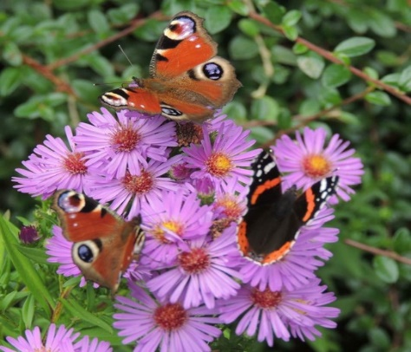

Tynedale Circuit Lent Course 2019.

Exploring the meaning of ‘New Life’ for ourselves, our communities and our environment.

Week One – ‘New life in Creation,’
Genesis 1 & 2 Created in his image, Created to tend the earth, Created to rest and enjoy
Week Two – New Life in Christ
Unconditional love, forgiveness what do they mean to us? The Prodigal Son Story
Week Three – New Life in Us
Filled with His Spirit, gifts of the Spirit, used by God
Week Four – New life in our Community
Prayer Walk and blessing activity.
Week Five - New Life, New Purpose,
What might God be calling you to next?

