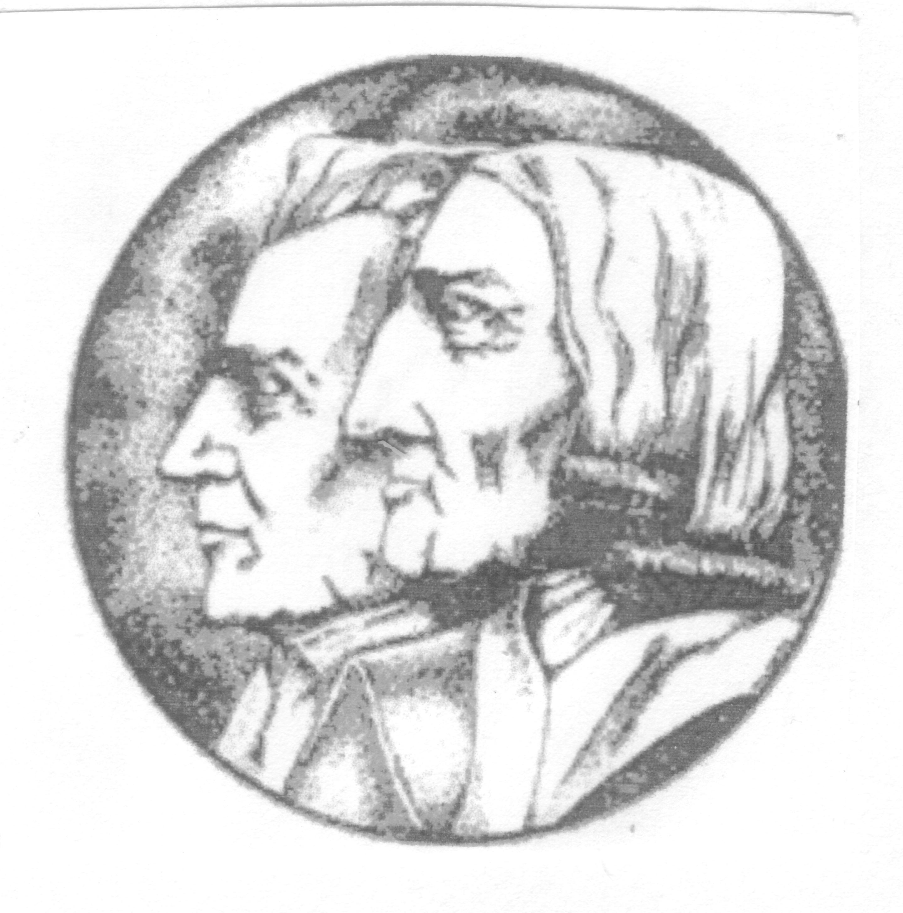

The Spring Lecture 2022.

JAMES EVERETT
AND THE WESLEYAN REFORM SCHISM

Presented by
Dr. Peter Forsaith
At Roker Methodist Church
Lonsdale Road, Roker. SR6 9TB Parking available on surrounding roads
Bus services available from Newcastle and Sunderland plus 10-15min walk.

Saturday 13th April 2024. 2.30pm.
Light refreshments will be available £5. Please book and pay in advance to Tel.01434 608733
by 1st. April 2024

All are welcome. Admission £2 for non-members

The North East Methodist History Society was formed over fifty years ago to provide a forum for those interested in Methodist History in the North East. With 100 members, drawn mainly from the region, it holds two major regional meetings each year and publishes a much-respected Bulletin to be found in local record offices and libraries. The Society also has a substantial collection of historical books and pamphlets housed in the Lit and Phil Library in Newcastle. A web site can be found at www.northeastmethodisthistory.weebly.com

